## Is it time to make aggregate statistics on the landlord register available to researchers?

A recent Scottish Parliament Information Centre (SPICe) briefing paper has highlighted the lack of currently available data on the private rental sector (REF/Link). The paper evaluates data requirements for evaluating recent legislation in this area and has underlined the difficulty in carrying out any evaluation using currently available national data. The paper also highlights the potential of aggregate statistics, which are collected, but not made available. The landlord register is one such dataset.

The UK and Scotland does have good general information on private rental households through national surveys but these data have low geographical resolution being only available at a Local Authority Level and give little insight to submarkets, which generally operate at lower geographical levels. Also, little is known about Landlords, their properties and their behaviour apart from small scale qualitative or quantitative surveys. One possible source to fill this gap is landlord register data. The Urban Big Data Centre (UBDC) has published two blogs/data notes based on analysis using Landlord registration data (Links/REF) from Renfrewshire and Aberdeen. These papers explore the potential usefulness of these data by analysing these snapshots of the register. Both analyses from the two local authorities are from distinct points in time and demonstrate the high level of compliance of landlords in the registration scheme.

We present further analysis here of another snapshot of the data that adds weight to the calls for the release of these data at a neighbourhood level (datazone).

### Landlord registration dataset

The City of Edinburgh Council provided aggregated data at datazone level from December 2017. Datazones are geographical units from the census geography and are the areas at which much neighbourhood data is available.

In the 2011 census there where 224,238 households in Edinburgh Local Authority area of which 49,979 households (22.3%) were in private rented households. We can estimate the numbers and percentages of households in private renting using the Scottish Survey Core Questions (SSCQ) for the period for which we have Zoopla data. The Survey pools respondents from a number of Scottish surveys on questions that are present in all the surveys. While limiting what is in the survey, the strength lies in the larger more robust sample that allows for more reliable estimates to be made. There has been a slight rise in the population within Edinburgh local authority boundaries. Using the SSCQ household weight to estimate the population for Edinburgh in 2016 (the most recent year available), we get 232,885 households in Edinburgh an increase of 3.9% households from 2011 (224,238). The number and percentage of households in private renting rose to a peak of nearly 70,000 in 2014 but fell in subsequent years. Though the trend over the period is still of a larger rental sector than in 2011

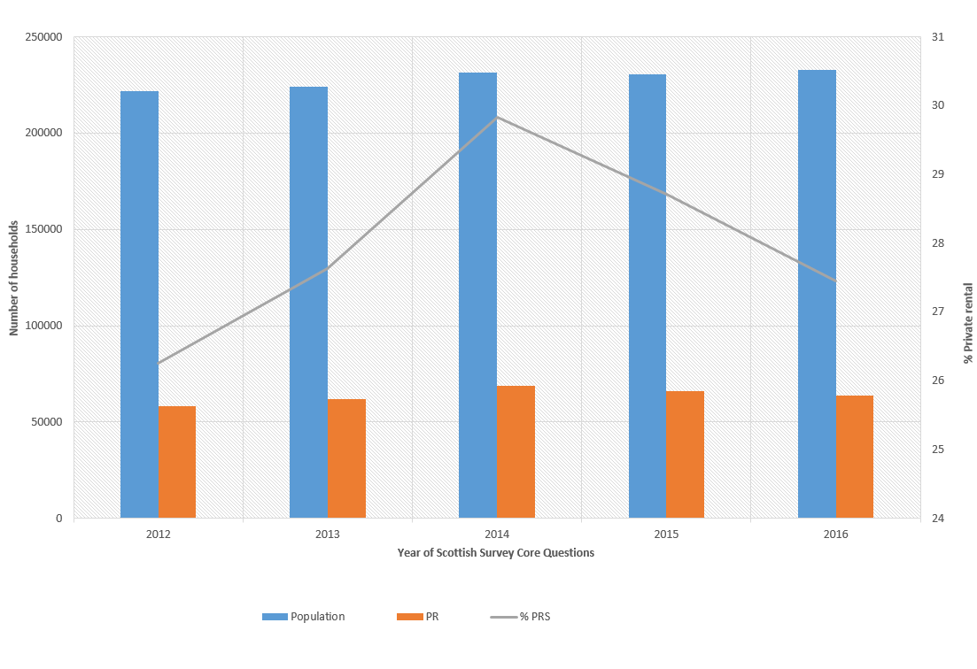

**Figure 1** Household Population and Private rental estimates from the Scottish Survey Core Questions 2012-2016.

Source:

The SSCQ (2016) reports some 63,922 households in private rental compared to 54516 registered properties in 2017, which is 85.3% of the 2016 estimated private rental population. There are some expected differences between the two sets of data, which we are unable to account for but would expected to change the numbers. Some landlords will have properties that are currently not being let, or have withdrawn their properties from the private rental market to either sell or to advertise as a short term let. So the estimate of 85% of private rented properties being registered has a level of error based on: the estimates used in the SSCQ; the level of empty properties at any time; and the level of properties registered but no longer available to rent. We can estimate the percentage of rental properties registered for 2017 as 23.4% using the estimated 2016 population.

### Comparisons with other data

We can compare the landlord register data to other “ground truth” data sets, the most significant of which is the census. Figure 1 shows the scatter plot of landlord registrations and private rental households (census 2012) for datazones in Aberdeen. Clearly the data from the landlord register comes 6 years after the census and we might expect, given recent private rental trends, that there will havr been a growth of properties in most areas. Indeed the majority of changes are on the positive side of the line of equality, and there are some areas, where if the data is to be believed, there have been some large increases in private rental households. Where there have been reduction in the level of private rental households the changes as relatively small. However, the linear trend in the graph is clear and for the vast majority of datazones lie close to the area of equality.

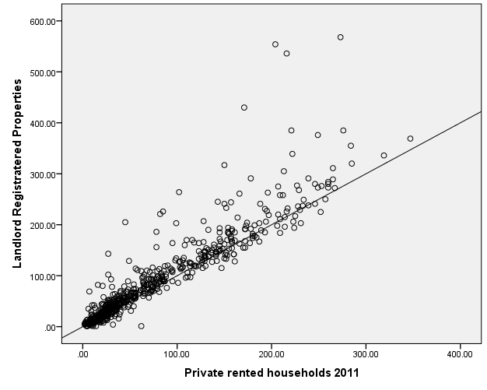

**Figure 2** Landlord registration by Private rental households (Census 2011) at datazones.

Source:

### Geography of private renting in Edinburgh

Figure 2 also suggests that there are significant geographical differences in the change in the numbers of private rental households since the 2011 census and while many datazones have changes, only a small number have had large changes. We can examine the geography of both the landlord register properties (2017) and the private rental households (Census 2012) in Figure 3 an Figure 4 respectively. Not surprisingly both maps show that the areas where the private rented sector is high are the same in both periods. However, there have been significant changes in some areas, with much of the change focused in the centre. [Revisit this when you have redrawn map]

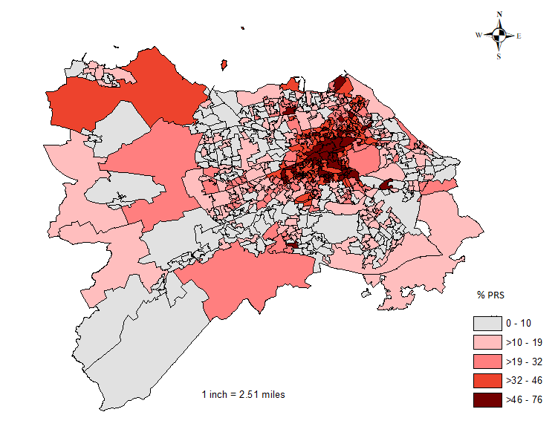

**Figure 3:** Percentage private rental households census 2011.

Source:

[Change the map to be on the same categories]

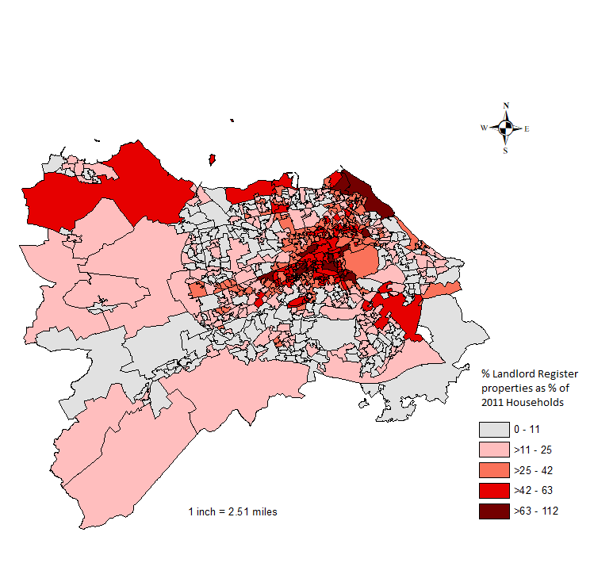

**Figure 4** Percentage of landlord register properties as a % of 2011 households

Source:

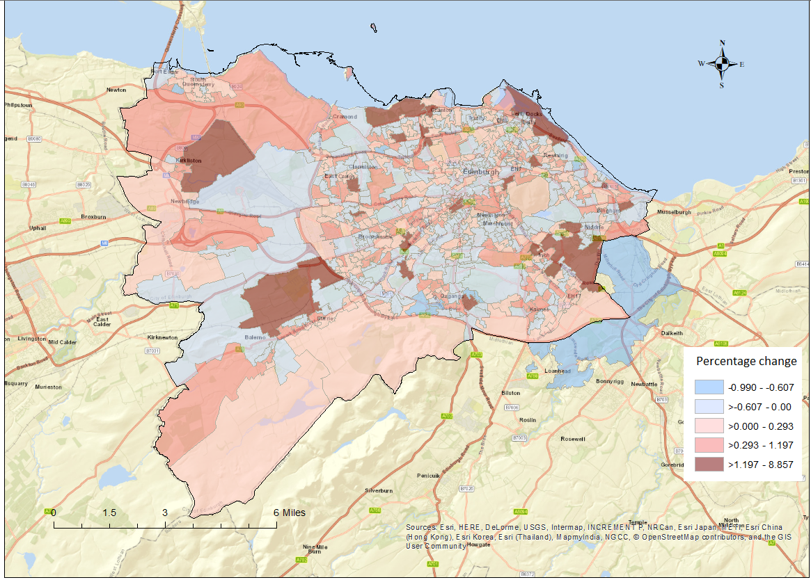

***Figure 5:*** Change in private rented properties, Edinburgh 2011-17

Source:

We get a better picture of where change in private rental in Edinburgh has taken place from Figure 5, which shows the % change from 2011 to 2016 in datazones as a % of the 2011 census. What is clear from the map is that there are many areas where there has been small decreases and increases and these are spread over the city in no discernible pattern. There are a smaller number of areas that have had more pronounced increases in rental and these appear to be largely (but not wholly) away from the city centre.

The Landlord register data has only limited use when released for one time-period and for just the number of landlords or number of registered property. Giving both sets of data would enrich the data and say much more about landlords. However, it is over time that these data would be most useful. It would give us much greater picture of landlord behaviour, and a more direct picture of private rented properties in what is the most dynamic sector of the housing market.

### Possible uses of these data

Edinburgh is one of the cities in the UK where, at least anecdotally, AirBnB has had a significant growth. This growth may have resulted in landlords in some areas choosing to use AirBnB over longer term renting to either maximise incomes or to reduce having to respond to new regulation. The landlord register has the potential to help us gain a much better picture of the impact of AirBnB over time.

Aggregated data from the current landlord register register on both properties and landlords by datazone has the potential to give greater understanding of:

* The private rental sector in general
* Which areas are changing and by how much
* The changing balance of properties to landlords

### The argument for new fields in the Landlord Register.

The register currently collects very little information about the property but there are strong arguments to add a small number of fields to the current data collection. These could be any one or all of the following:

* Number of bedrooms in each of the properties
* The current rent on the property.

Adding these fields would require little extra time of landlords but would plug many of the gaps we have in our knowledge of the highly dynamic private rental market. Currently resources in the Scottish Government are short and capacity to carry out the analysis of the housing system and the private rental market are low. It would be possible for these data to be made available for other researchers to analyse and fill the gaps in our understanding of the sector, providing valuable understanding for Governments and policy makers.